Dear Members and Stakeholders,

I am pleased to introduce our 2021/2022 Board of Directors of Julalikari Council Aboriginal Corporation who were elected at the AGM on Tuesday 30th November.

The Chairperson of the Organisation is Linda Turner (LT) who has been re-elected.

The Board and I look forward to another hard working year in 2022 to achieve outcomes for our community.

The Board welcomes comments and feedback from any member in the community on Julalikari services and your needs.

Sam Ashton
Chief Executive Officer
3/12/2021
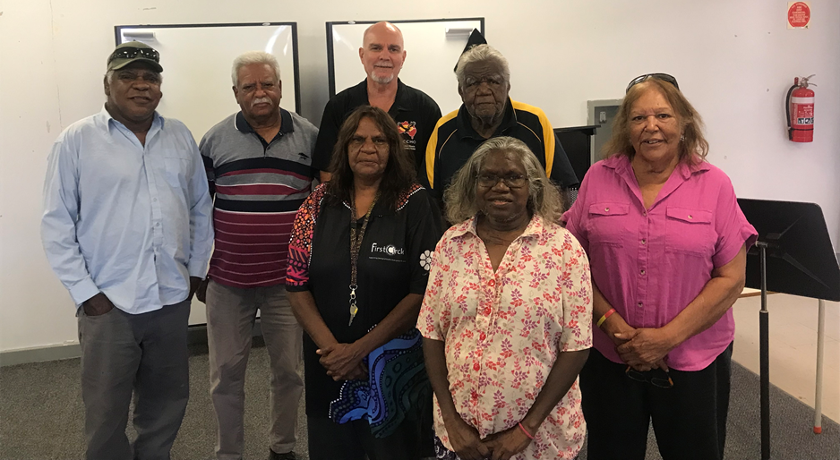
Back Row: Norman Frank, David Curtis Snr, Tony (TM) Miles, Michael Jones.
Front Row:Patricia Frank, Annie Morrison and Linda (LT) Turner

